**Project Name:** Deezer Website Testing

**Student Info:**

**Name:** İrfan Emre UTKAN

**ID:** 22070006085

**Department:** Software Engineering

**Course Section:** 1

**Introduction:**

* In this project I tested the Deezer.com website. Deezer is a music streaming app that is used worldwide. The reason I chose a music streaming app for the project is that these apps like Deezer have enough features that can be tested by evaluating their functionality and performance and yet they are simple to comprehend. Among other music streaming services, the design and ease of use were the main reasons for me when choosing Deezer as the preferred streaming provider.

**Test Categories**

1. **Functionality testing:**
   * Testing scenarios for a successful login and register process.
2. **Use case Testing:**
   * Testing scenarios after a successful login. Covering user functionalities
3. **Performance testing:**
   * Load, Stress, Spike, Soak testing
4. **Usability Analysis**
   * Opinion on the usability of the deezer.com
5. **Accessibility Testing**
   * Testing the website on different browsers and devices
6. **Security Testing**
   * Mozilla Observatory Report

**Functionality Testing**

1. Testing signup Page
   1. Username field
      1. No input for username (less than 2)
      2. Boundary value of 2 in username field
      3. Boundary value of 50 in username field
      4. Username with more than 50 characters
      5. Valid username
   2. Email Field
      1. No input for email
      2. Invalid email format
      3. Email that is already in use
      4. Using an email that does not exist. // manually tested it turns out that a user can create an account with a email that is not registered to a mail service.
      5. Email with special characters
   3. Password field
      1. No input for password (below boundary)
      2. Password with 8 characters (boundary)
      3. Password with 50 characters (boundary)
      4. Password more than 50 characters (above boundary)
      5. Password between 8 and 50 characters (between boundaries)
   4. Age field
      1. No input for age (below boundary)
      2. Age below 0 (below boundary)
      3. Age above 150 (above boundary)
      4. age below 16 (below boundary)
      5. Age between 16 and 150 (between boundaries)
   5. Gender Field
      1. Unchecked
      2. Male
      3. Female
   6. Verification Checkbox Field
      1. Unchecked
      2. Checked
2. Login Field
   1. Empty email with valid password
   2. Empty password with valid email
   3. Valid login

**Functionality Testing Decision Table for Registration**

|  |  |  |  |  |  |  |  |
| --- | --- | --- | --- | --- | --- | --- | --- |
| Conditions | R1 | R2 | R3 | R4 | R5 | R6 | R7 |
| Valid Email | T | F | T | T | T | T | T |
| Invalid Email | F | T | F | F | F | F | F |
| Valid Username | T | T | F | T | T | T | T |
| Invalid Username | F | F | T | F | F | F | F |
| Valid Password | T | T | T | F | T | T | T |
| Invalid Password | F | F | F | T | F | F | F |
| Valid Age | T | T | T | T | F | T | T |
| Invalid Age | F | F | F | F | T | F | F |
| Gender Selected | T | T | T | T | T | F | T |
| Gender Not Selected | F | F | F | F | F | T | F |
| Checkbox Checked | T | T | T | T | T | T | F |
| Checkbox Not Checked | F | F | F | F | F | F | T |
|  | | | | | | | |
| Success | X |  |  |  |  |  |  |
| Email Error |  | X |  |  |  |  |  |
| Username Error |  |  | X |  |  |  |  |
| Password Error |  |  |  | X |  |  |  |
| Age Error |  |  |  |  | X |  |  |
| Gender Error |  |  |  |  |  | X |  |
| Checkbox Error |  |  |  |  |  |  | X |

**Functionality Testing Results**

Source codes are provided within Functionality-Testing File.

Email test 3 Fails. The reason for that is deezer.com/register does not show the error message “Email already used” all the time. It only shows the error message “Lütfen tüm alanları kontrol et”.

While implementing the code and somehow did get the “FORM_ERROR_EMAIL_ALREADY_USED” error message a few times while browsing the HTML of the site so I added it like that to the code like that.

**Use case Testing.**

**Source codes are provided within UseCase-Testing File. (I tested first 3 with selenium, remaining tested manually)**

**Scenario 1:** User searches for an artist and plays the first song that comes up in the tracks list.

1. User Logs in to their account.
   1. User Decides to use the system without an account.
2. User Searches an Artist
   1. Artists do not exist.
3. User clicks tracks for the artist.
4. User clicks the first track.
5. Track starts to play.

|  |  |  |  |  |  |  |
| --- | --- | --- | --- | --- | --- | --- |
| Test Case ID | Login | Artist | Track | is Playing | Has Tracks | Expected Output |
| 1 | V | V | V | V | V | First track of the given artist is playing |
| 2 | V | I | N/A | N/A | N/A | Artist does not exist error message |
| 3 | I | V | V | V | V | First track of the given artist is playing |
| 4 | I | I | N/A | N/A | N/A | Artis does not exist error message |
|  | | | | | | |
| Test Case ID | Login | Artist | Track | is Playing | Has Tracks | Tested Output |
| 1 | softwaretesting1231254 | Thurisaz | First Track | YES | YES | First track of the given artist is playing |
| 2 | softwaretesting1231254 | d)(/(732d125 | N/A | N/A | N/A | Artist does not exist error message |
| 3 | N/A | Thurisaz | First Track | YES | YES | First track of the given artist is playing with an error message for limited listening time |
| 4 | N/A | d)(/(732d125 | N/A | N/A | N/A | Artis does not exist error message |

**Scenario 2:** user Adds a track to their favorites then views the favorites list.

1. User logs in to their account.
   1. User decides to use the system without an account.
2. User searches for an artist.
3. User clicks on a track.
4. User clicks favorite button.
   1. Track is already on my favorite list.
5. Users add track to their favorite list.
6. User views favorite list

|  |  |  |  |  |  |
| --- | --- | --- | --- | --- | --- |
| Test Case ID | Login | Artist | Track | Already in Favorites | Expected Output |
| 1 | V | V | V | I | Track is added to favorites list |
| 2 | V | V | V | V | Track is removed from favorites list |
| 3 | I | V | V | N/A | User is redirected to login page |
|  | | | | | |
| Test Case ID | Login | Artist | Track | Already in Favorites | Tested Output |
| 1 | softwaretesting1231254 | Thurisaz | Endless | No | Track is added to favorites list |
| 2 | softwaretesting1231254 | Thurisaz | Endless | Yes | Track is removed from favorites list |
| 3 | I | Thurisaz | Endless | N/A | User is redirected to login page |

**Scenario 3:** user views the lyrics of the track.

1. User logs in to their account.
   1. User decides to use the system without an account.
2. User searches for an artist.
3. User clicks on the track.
4. User clicks lyrics button.
   1. Song has no lyrics button.
5. User views lyrics

|  |  |  |  |  |  |
| --- | --- | --- | --- | --- | --- |
| Test Case ID | Login | Artist | Track | Lyrics | Expected Output |
| 1 | V | V | V | V | Lyrics are shown |
| 2 | V | V | V | I | No lyrics button available |
| 3 | I | V | V | V | Lyrics are shown |
| 4 | I | V | V | I | No lyrics button available |
|  | | | | | |
| Test Case ID | Login | Artist | Track | Lyrics | Tested Output |
| 1 | softwaretesting1231254 | Tamino | Habibi | Has Lyrics | Lyrics are shown |
| 2 | softwaretesting1231254 | Thurisaz | Endless | No Lyrics | No lyrics button available |
| 3 | I | Tamino | Habibi | Has Lyrics | Lyrics are shown |
| 4 | I | Thurisaz | Endless | No Lyrics | No lyrics button available |

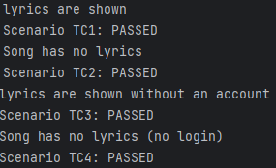

**Scenario 4:** user adds a track to their playlist.

1. User logs in to their account.
   1. User decides to use the system without an account.
2. User searches for an artist.
3. User clicks on the track.
4. User clicks on track options.
5. User clicks on add to playlist.
   1. User adds the track to a newly created playlist.
   2. User adds the track to previously created playlist.
      1. Track is already on that playlist.
6. Track is added to the playlist.

|  |  |  |  |  |  |  |
| --- | --- | --- | --- | --- | --- | --- |
| Test Case ID | Login | Artist | Track | New Playlist Created | Added to Playlist | Expected Output |
| 1 | V | V | V | V | V | Track added to newly created playlist |
| 2 | V | V | V | I | V | Track added to a previous playlist |
| 3 | V | V | V | I | I | Error message: Track was already on that playlist |
| 4 | I | V | V | N/A | N/A | Forwarded to login page |
|  | | | | | | |
| Test Case ID | Login | Artist | Track | New Playlist Created | Added to Playlist | Tested Output |
| 1 | softwaretesting1231254 | Thurisaz | Endless | Test2 | Test2 | Track added to Test2 |
| 2 | softwaretesting1231254 | Thurisaz | Endless | No | Test1 | Track added to Test1 |
| 3 | softwaretesting1231254 | Thurisaz | Endless | No | No | Error message: Track was already on that playlist |
| 4 | I | Thurisaz | Endless | N/A | N/A | Did not forward to login page, continued until the naming of the playlist, but did not create a playlist neither did show an error message |

**Scenario 5:** user changes their Birthday.

1. User logs in to their account.
2. User switches to account details page
3. User changes birthday details.
   1. Age is lesser than 16.
4. Birthday updated.

|  |  |  |  |  |
| --- | --- | --- | --- | --- |
| Test Case ID | Login | Previous birthdate | New birthdate | Expected Output |
| 1 | V | V | V | Birthdate updated |
| 2 | V | V | I | Birthdate did not update, error shown about legal age |
|  | | | | |
| Test Case ID | Login | Previous birthdate | New birthdate | Tested Output |
| 1 | softwaretesting1231254 | 1/1/2001 | 1/1/2002 | Confirmation message: Your data has been updated. |
| 2 | softwaretesting1231254 | 1/1/2002 | 1/1/2015 | Error message: You must be at least 16 years old to create an account. |

**Scenario 5:** user deletes their account.

1. User logs in
2. User goes to account details page.
3. User clicks on delete account button.
4. User types password
   1. Password is not correct.
5. Confirmation email sent.

|  |  |  |  |  |
| --- | --- | --- | --- | --- |
| Test Case ID | Login | password | Typed Password | Expected Output |
| 1 | V | V | V | Email sent to confirm account deletion |
| 2 | V | V | I | Error message: wrong password. |
|  | | | | |
| Test Case ID | Login | password | Typed Password | Tested Output |
| 1 | testest1d2123142@gmail.com | 5454wqwqAA | 5454wqwqAA | Email sent to confirm account deletion |
| 2 | testest1d2123142@gmail.com | 5454wqwqAA | 123123123123 | Error message: wrong password. |

**Performance Testing**

**Load Testing**

Source codes are provided within Performance-Testing File.

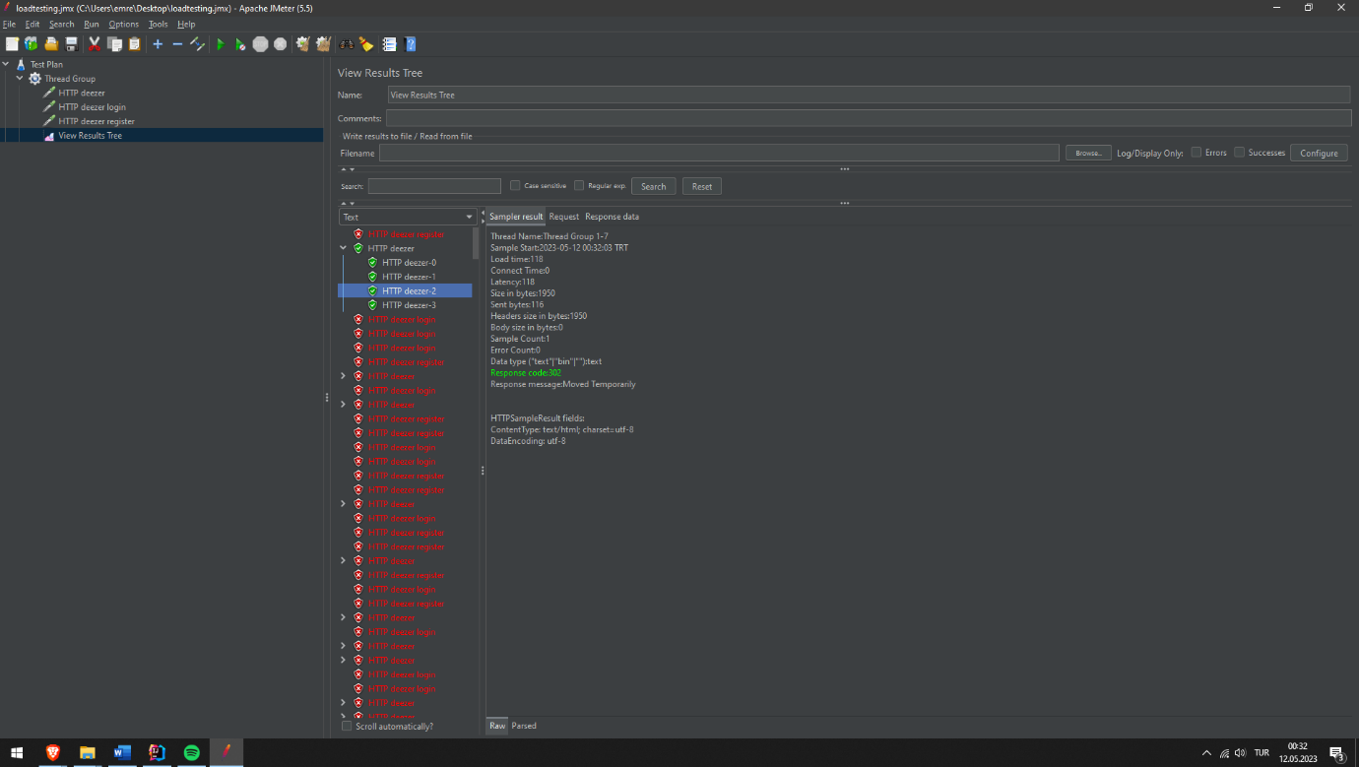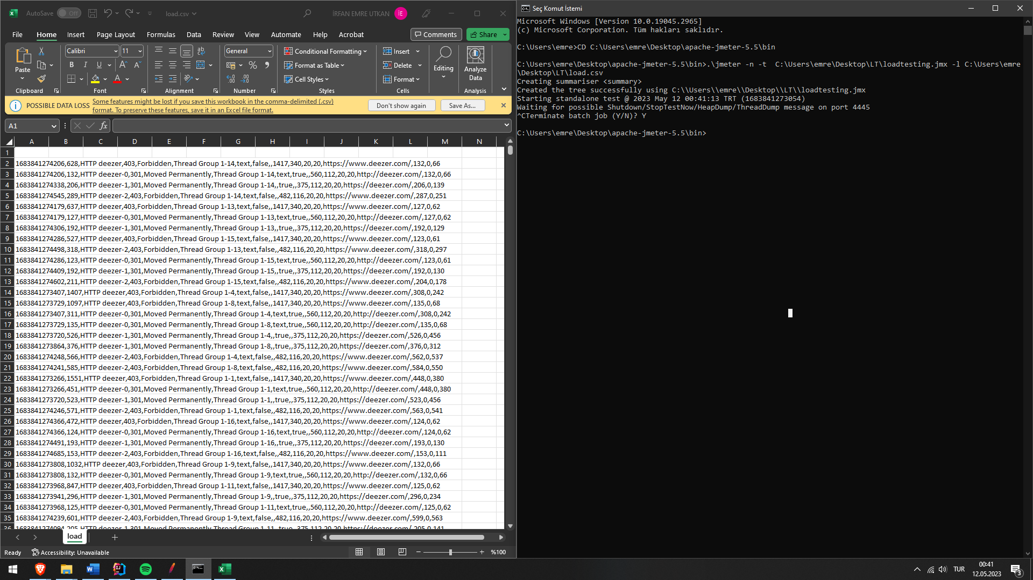

**Stress Spike Soak Testing**

**Usability Analysis**

I consider the usability of Deezer.com to be simple and user friendly. Actions like registering and listening to music are easy processes because of the clean, responsive, easy to navigate layout of deezer.com. For registering, inputs are not very demanding user can choose a very simple password and username. In main page area for searching tracks is right on top of the page which makes it easy for a new user to find. Algorithm for finding music for a given input is good enough that if you mistype a word or a character it still understands what you meant most of the time. Overall, the website is very responsive and fast.

**Accessibility Testing**

Tested using Browser stack.

1. Yandex 14.12 on Windows XP (does not work)
2. Safari 16.3 on macOS Ventura
3. Chrome on Galaxy S9+
4. Safari on iPhone 8
5. Chrome on iPhone 14 Pro
6. Opera 94 on Windows 7
7. Internet Explorer 8 on Windows XP (does not work)
8. Opera 97 on Windows 10
9. Internet Explorer 11 on Windows 8.1 (does not support internet explorer)
10. Firefox 110 on Windows 8.1
11. Safari 8 on OS X Yosemite (UI does not work as intended)

**Security Testing**

